THE BRIDGEWATER CANAL IN SALFORD
GREEN BADGE TOURIST GUIDE TRAINING COURSE
2018-2019
APPLICATION FORM
Please attach a recent
passport size, colour photograph here and include two additional copies
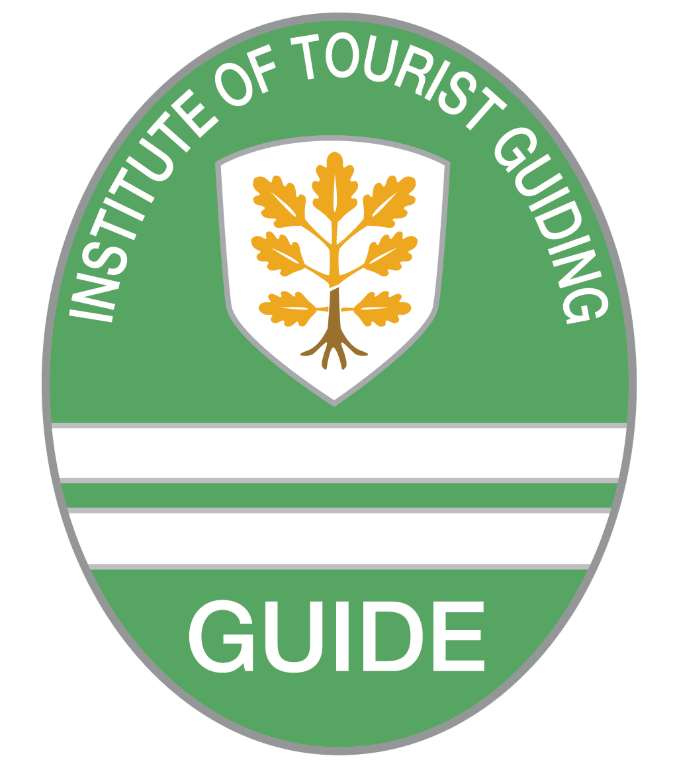

PERSONAL DETAILS

Surname (Mr / Mrs / Miss / Ms) ________________________________________________________

First name _______________________ Name by which you wish to be called ___________________

Home address ______________________________________________________________________

____________________________________________________________ Post code _____________

Email _____________________________________________________________________________

Telephone (Home) _________________ (Mobile) _________________ (Work) __________________

Place and date of birth ___________________________________ Nationality __________________

First language _____________________________________________________________________

Other languages in which you are fluent _________________________________________________

Current occupation _____________________________________________ Full / Part-time / Retired

How long have you lived in Salford, or what connections do you have with the city? ______________

__________________________________________________________________________________

Do you have any special needs of which the Course Director might need to be aware? Yes / No

__________________________________________________________________________________

Do you have a criminal conviction which is not legally spent? Yes / No

EMPLOYMENT

Please give details of your employment over the last ten years, commencing with your most recent or present job and including contract or freelance work. Continue on a separate sheet if required.

Dates |  | Employer’s name and address | Nature of business, job title and responsibilities
From | To

KEY SKILLS, EXPERIENCE AND QUALIFICATIONS
Please give details of any key skills, relevant experience and qualifications.
Key Skill/Experience/Qualification | Where and when did you gain this skill/experience/qualification?

Please provide details of any other relevant experience (such as public speaking, lecturing, teaching, acting, handling groups):

Membership of professional Institutes/bodies/organisations _________________________________
Please state any special interests or hobbies ______________________________________________

THE PROGRAMME OFFERS A COMPREHENSIVE INTRODUCTION TO GUIDING IN THE AREA OF SALFORD THROUGH WHICH THE BRIDGEWATER CANAL RUNS. TO BE SUCCESSFUL, STUDENTS WILL NEED TO SUPPLEMENT THE TRAINING PROGRAMME WITH EXTENSIVE PRIVATE STUDY, RESEARCHING ROUTES AND VISITING LOCATIONS.
How much time will you have for study each week, apart from the time at course lectures and visits?
__________________________________________________________________________________

Please write a statement of NO MORE THAN 250 WORDS to explain why you wish to train for the Green Badge, and describe the qualities and characteristics which you believe make you particularly suitable for guiding work. Please include details of any specialist knowledge. If you choose to write by hand, please write legibly. You may use a separate sheet of paper.

APPLICATION TO JOIN THE BRIDGEWATER CANAL IN SALFORD TRAINING COURSE
- I wish to apply for enrolment on the 2018/2019 Bridgewater Canal in Salford Green Badge Guide training course. If selected, I understand that regular attendance is essential and I undertake to take the examinations according to the timetable. Failure to do so may result in my being asked to leave the course
- In the case of students liable for payment of Institute of Tourist Guiding registration and examination fees (e.g. existing Blue or Green Badge Guides), I undertake to pay all fees by their due date and understand that these fees are non-refundable
- I understand that registration does not guarantee guiding engagements, and that there is no obligation on the providers, endorsers or funders of the programme to find work for registered guides.
- I understand that if I wish to guide in any languages other than my first language, it will be expected that I take the Institute of Linguists language examinations conducted on behalf of the Institute of Tourist Guiding.

Signed ____________________________________________ Date _______________________

Please return by email to: Shaun.Clydesdale@salford.gov.uk

Please ensure that you have:
- completed all sections
- attached a photograph and enclosed a further two copies

IMPORTANT
Unless you are: 1. a British Passport holder; 2. from another EU country
please attach a photocopy of your work permit or residence permit to the application form

